**CIS-350  
Infrastructure Technologies**

**Lab 2 Report**

**Student Name**: **Shivani Patel**

1. Insert *Lab2_Tree* file from p. 8 of the Lab 2 instructions into the space provided or use the *Alt-PrtScr* keys to capture the screen output (window) from command *TYPE Lab2_Tree* on p. 8 and paste that window here.

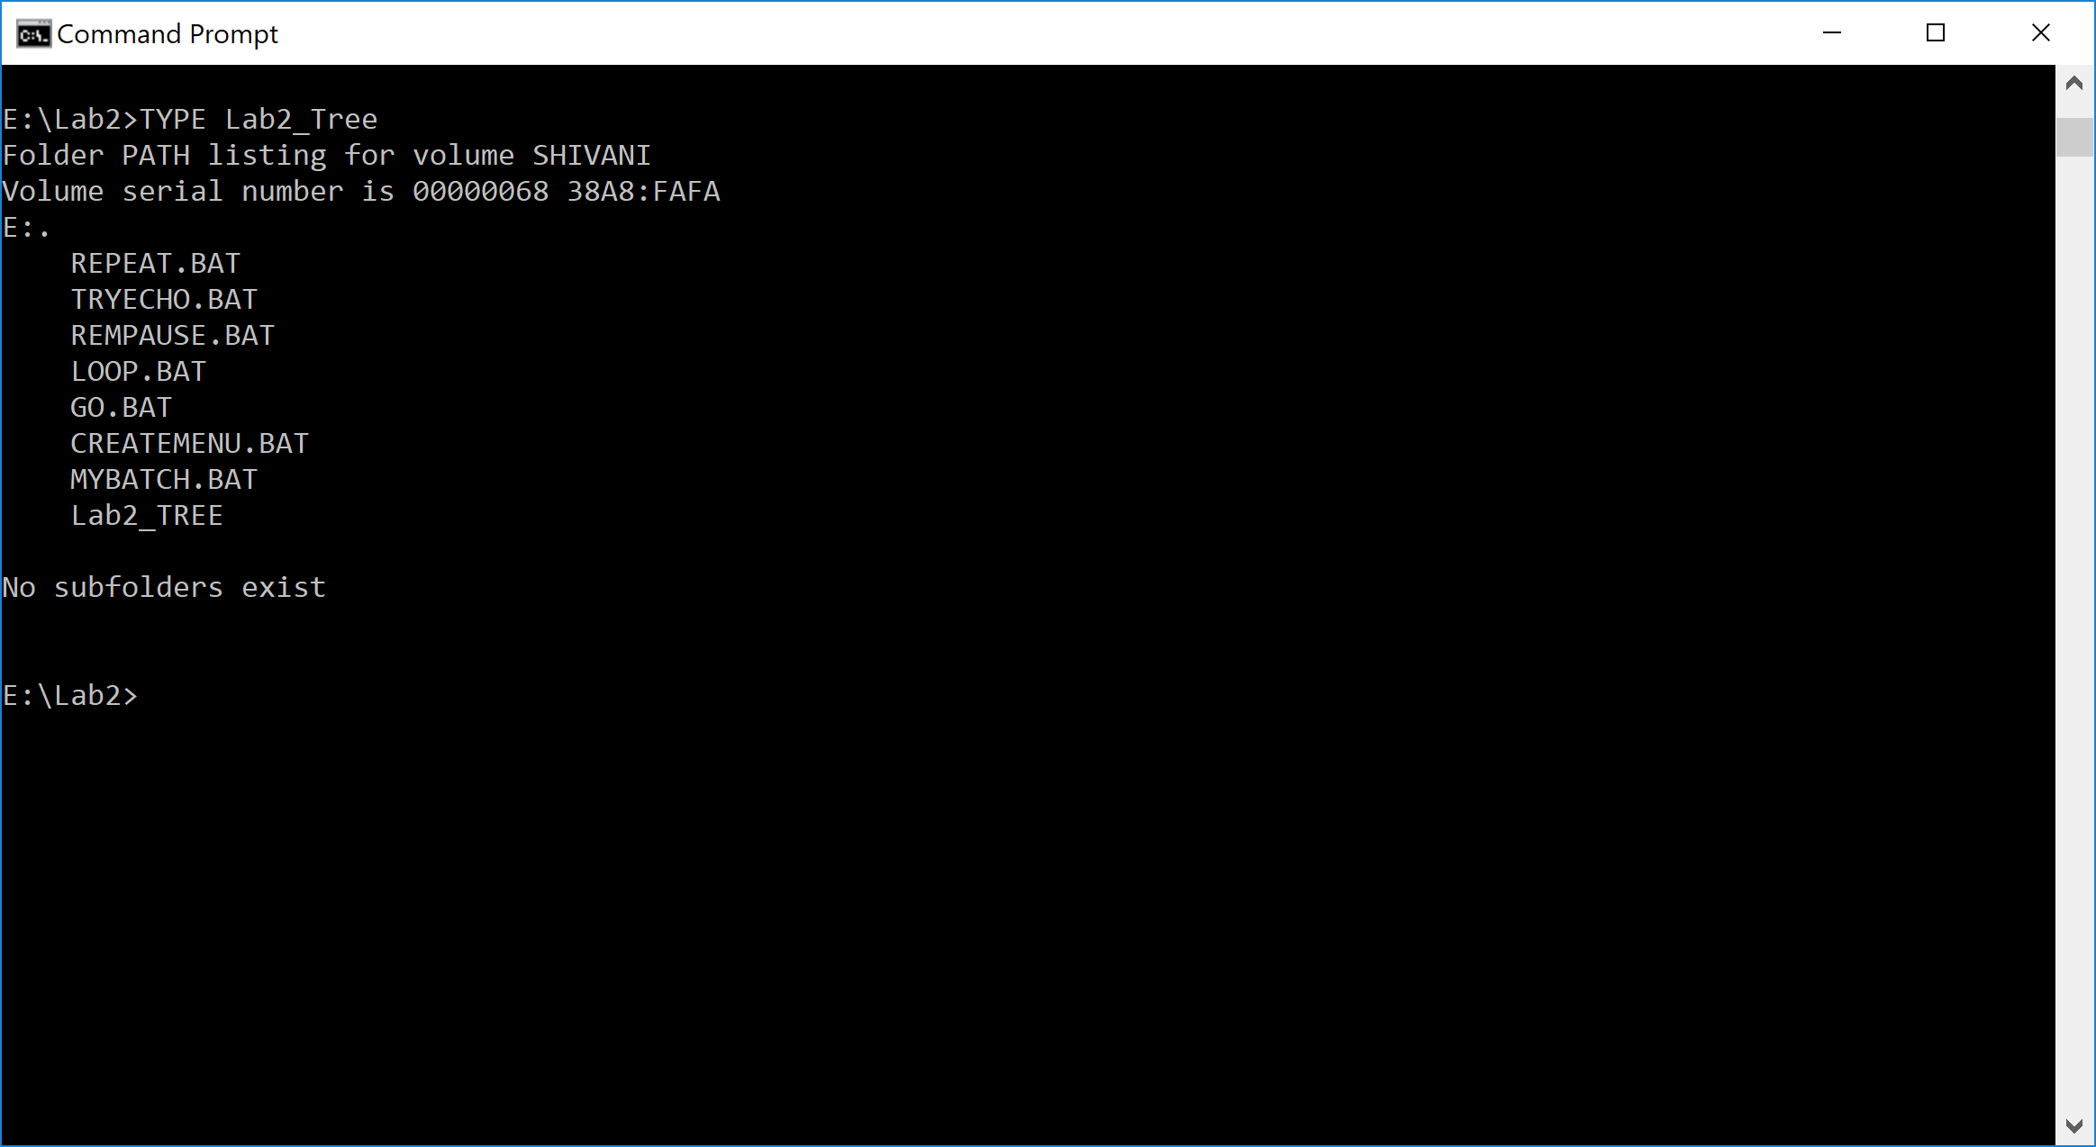

1. Assume that the system prompt displays "C:\>", i.e., your current directory and current drive are the root directory and C drive, respectively. Write a batch file below that will include commands to:
2. prevent all commands from displaying on the screen **– ECHO OFF**
3. display the following message "A simple batch file" **– REM – A simple batch file**
4. display the directory hierarchy of the C disk **- TREE**
5. display the directory hierarchy of the C disk with all files **– TREE /F**
6. create sub directory named *CLASSES* in the root directory **– MD CLASSES**
7. erase subdirectory *BOOK* from the root directory **- ERASE BOOK**
8. copy file *Go.bat* to directory *CLASSES* **– COPY Go.bat \CLASSES**
9. pause the screen **- PAUSE**
10. display the directory and pipe it through the *MORE* command **– DIR | MORE**
11. sort data in the ascending order coming from file *Letter3* and route the output to file *Letter3_Sorted* **– SORT <Letter3>Letter3_Sorted**

The batch file, commands (a) through (j):

1. **ECHO OFF**
2. **REM – A simple batch file**
3. **TREE**
4. **TREE /F**
5. **MD CLASSES**
6. **ERASE BOOK**
7. **COPY Go.bat \CLASSES**
8. **PAUSE**
9. **DIR | MORE**
10. **SORT <Letter3>Letter3_Sorted**
11. Describe step by step what a file named MYBATCH does.

**ECHO OFF –** stops all commands to display on the screen

**REM STARTING BATCH FILE –** displays STARTING BATCH FILE on the screen

**TREE /F –** displays all the directory hierarchy with all the files starting with the current directory which is Lab2 and everything (all files) under it.

**PAUSE –** it pauses the screen till the user hits any key to continue

**DIR –** displays the directory contents

**MD JOE MARY STACY –** creates 3 new directories named JOE, MARY and STACY in directory Lab2

**TREE /F –** it displays the directory hierarchy with all files starting with the current directory and everything below it and it will also include the new 3 files which we created (Joe, Mary, Stacy).

**PAUSE –** it stops the batch file execution and pauses the screen until the user hits any key

**COPY *.BAT E:\LAB2\STACY –** it copies all .BAT files from the current directory which is Lab2 to directory STACY.

**TREE /F –** now it displays the directory hierarchy with all files starting with the current directory and everything below it and the batch files in directory STACY.

**PAUSE -** it stops the batch file execution and pauses the screen until the user hits any key

**CD STACY –** it changes the current directory to STACY and displays “E:\Lab2\STACY>” prompt

**ERASE *.BAT –** it erases all the files which has the .BAT extension from the STACY directory

**PAUSE -** it stops the batch file execution and pauses the screen until the user hits any key

**CD .. –** this returns to the Lab2 which is the parent directory which is 1 level up.

**TREE /F -** it displays the directory hierarchy with all files starting with the current directory and everything below it but the batch files in directory STACY are not there anymore

**PAUSE -** it stops the batch file execution and pauses the screen until the user hits any key

**RD JOE MARY STACY –** it removes the 3 directories which we created above (JOE, MARY and STACY) from the Lab2 directory

**TREE /F -** it displays the directory hierarchy with all files starting with the current directory and everything below it and the three directories (JOE, MARY, and STACY) are not there under Lab2 directory anymore

**PAUSE -** it stops the batch file execution and pauses the screen until the user hits any key

**REM CLOSING BATCH FILE –** displays CLOSING BATCH FILE on the screen.